

CLOUD COMPUTING LAB
BSE ( V-B )

Submitted By:
Musfira Farooq
Roll No:
2023-BSE-045
Submitted To:
Sir Muhammad Shoaib

LAB 04

Virtualization & Linux Fundamentals

Task 1
Shows VM’s CPU, RAM, disk size, and network adapter details.
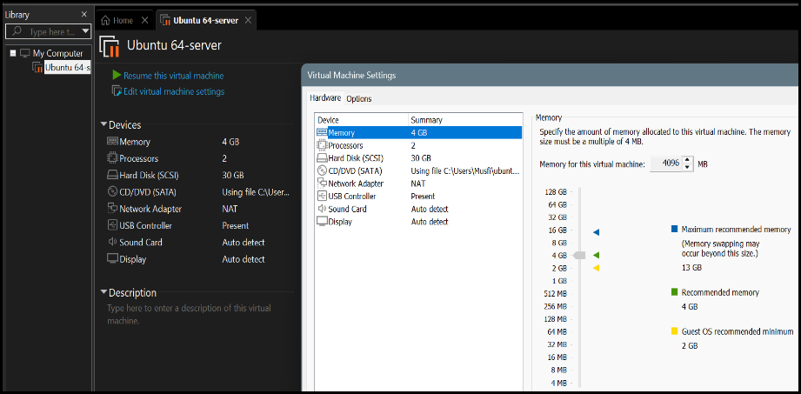

Task 2
SSH connection from host terminal to Ubuntu VM.
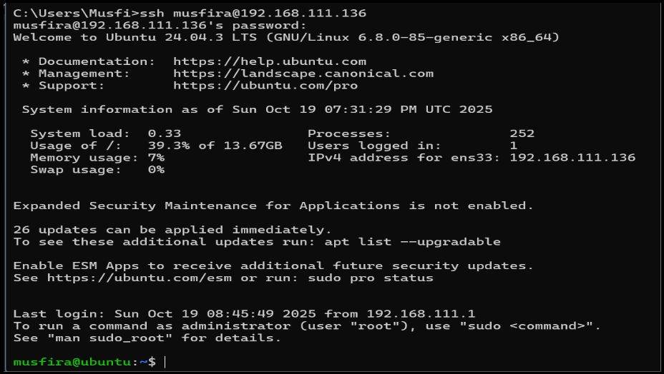
Output of whoami and pwd commands confirming user and directory.
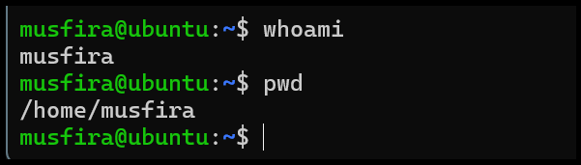

Task 3
- Contents of root / directory.
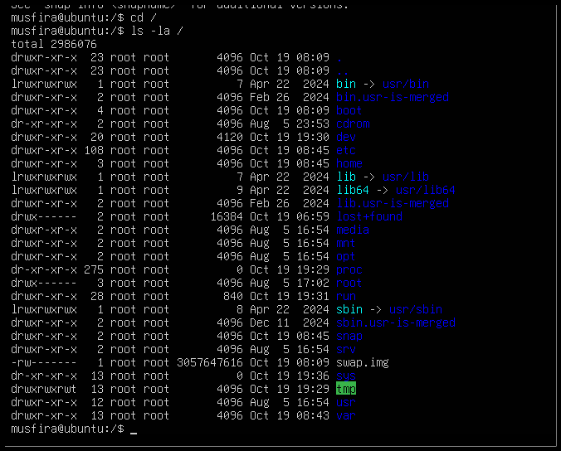
- Executable binaries in /bin.
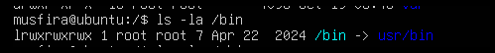
- System binaries in /sbin.
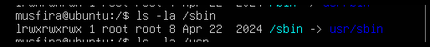
- Subdirectories and programs in /usr.
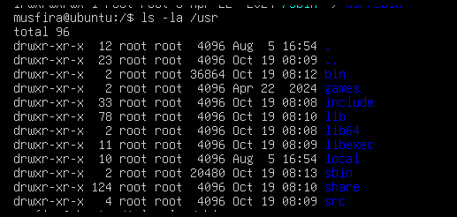
- Optional software folder /opt.
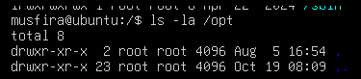
- Configuration files directory /etc.
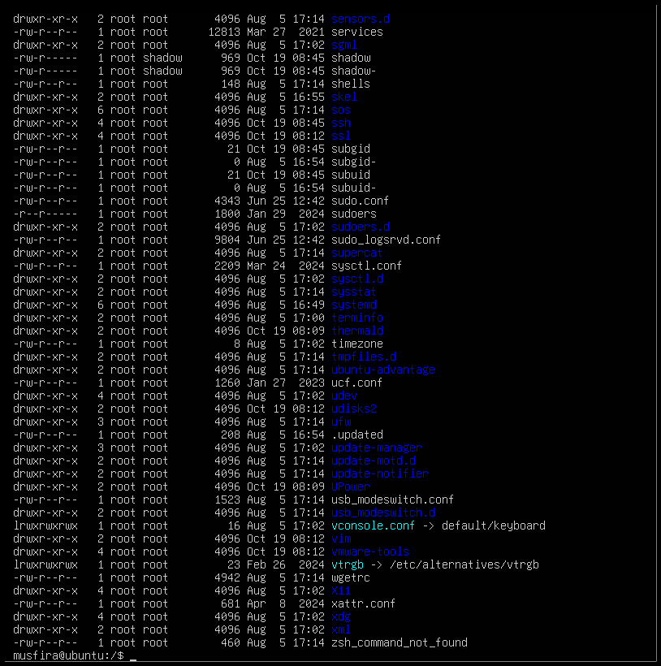
- Device files directory /dev.
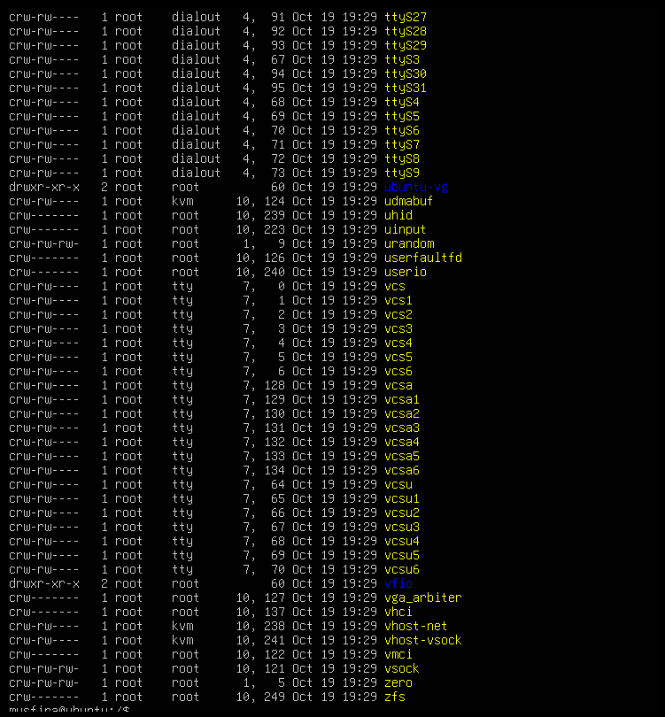
- Variable files like logs in /var.
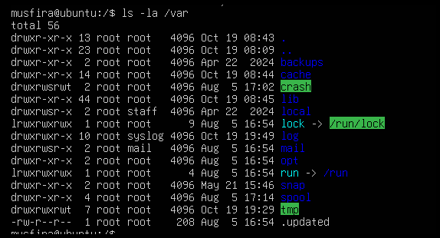
- Temporary files directory /tmp.
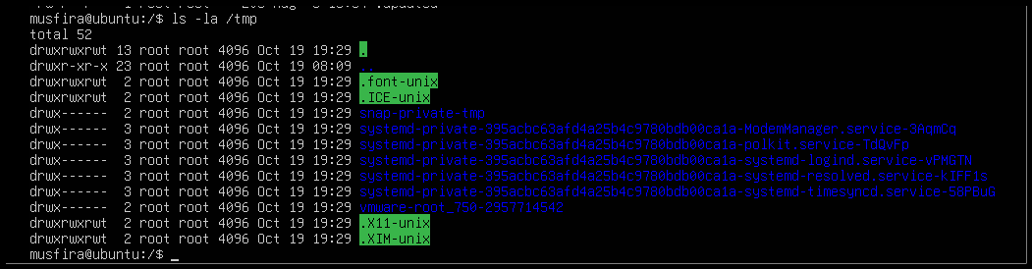
- Contents and hidden (dot) files in home directory.
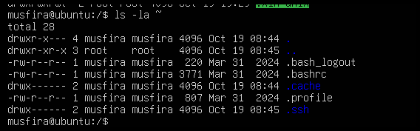
- Explanation of /bin, /usr/bin, and /usr/local/bin written in nano editor.
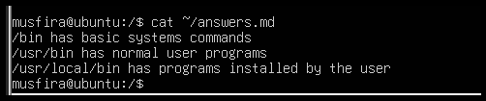

Task 4
- Created and saved README.md file.
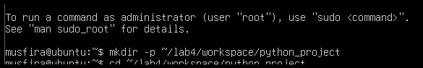
- Created and saved main.py with print statement.
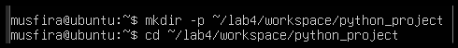
- Created .env file with environment variable.
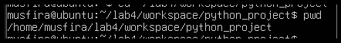
- Listed all files (including hidden).
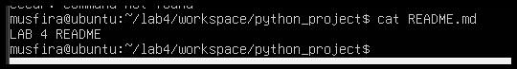
- Copied README.md to README.copy.md.
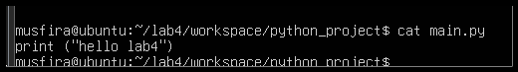
- Renamed copied file to README.dev.md.
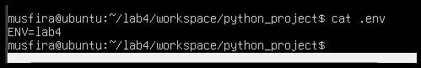
- Deleted the renamed file.
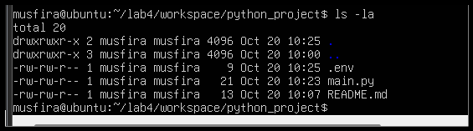
- Created new folder java_app.
- Copied entire folder recursively.
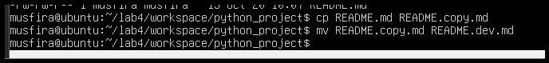
- Verified copied folders in workspace.
- Displayed recent command history.
- Demonstrated Linux tab auto-completion.
- Verifying copy.
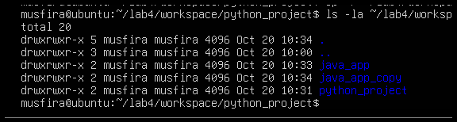
- History.
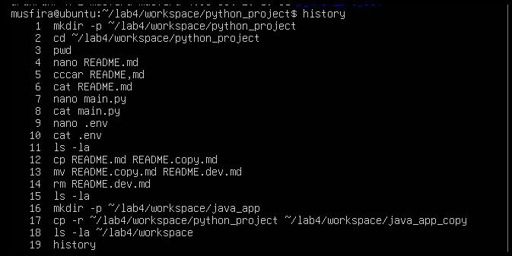
- Tab completion.

Task 5
- Shows kernel and OS information.
- CPU details with model name.
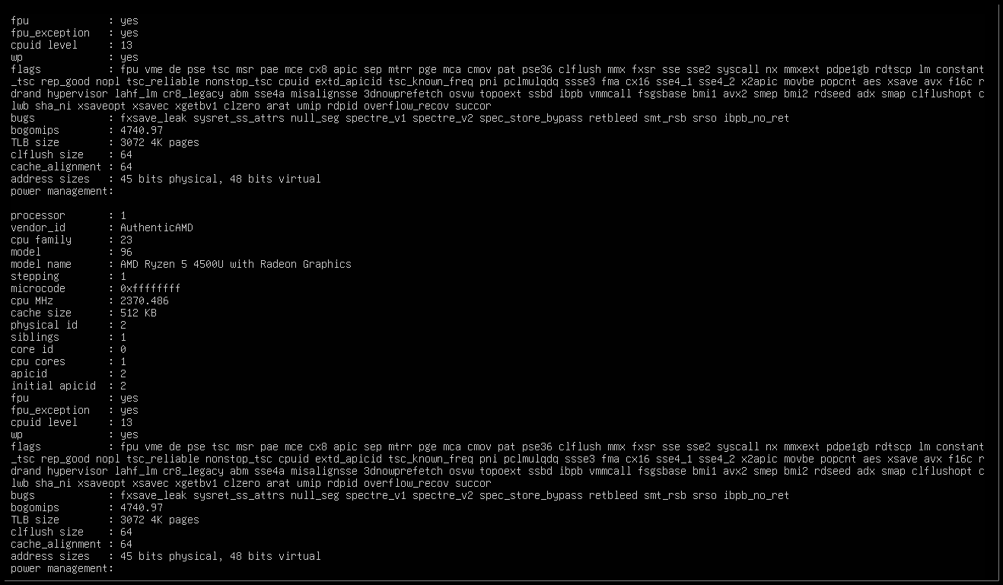
- Memory statistics using free -h.
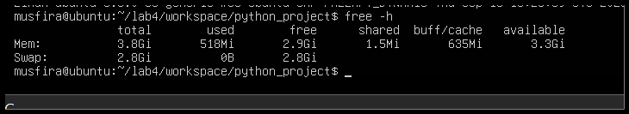
- Disk space usage using df -h.
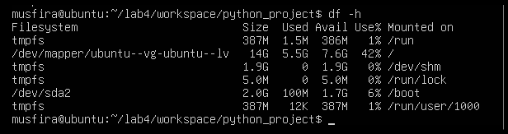
- Ubuntu version information.
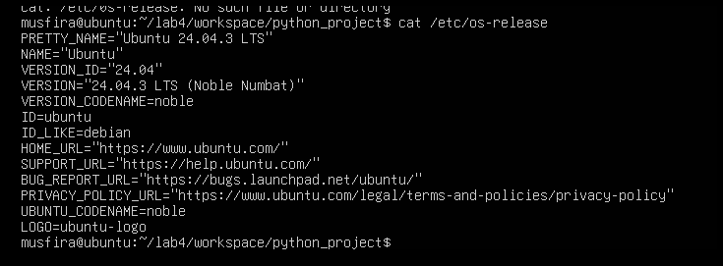
- List of active processes using ps aux.
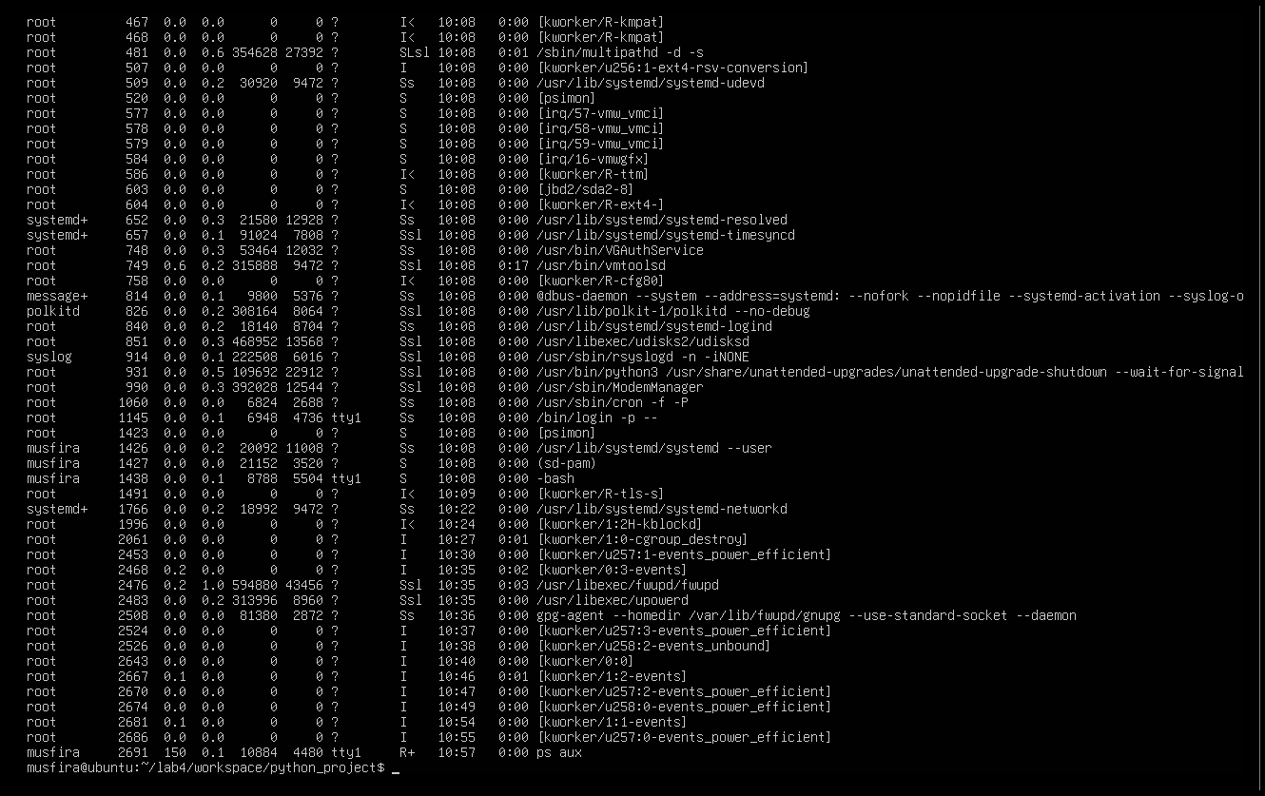

Task 6
- User lab4user created successfully.
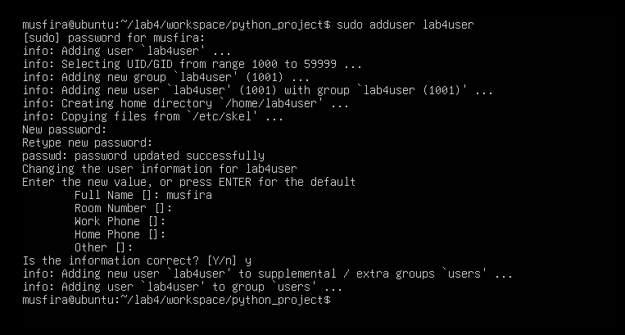
- Verified user entry in system database.
- Logged in as lab4user.
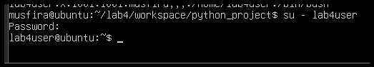
- Attempt to use sudo (expected failure).
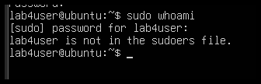
- Returned to main account.
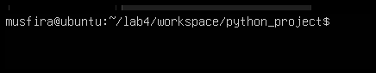
- (Optional) Deleted the test user.
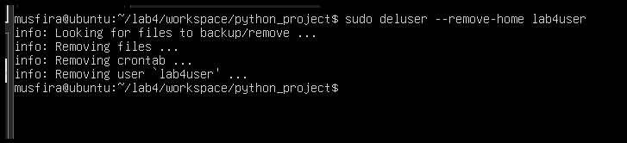
Bonus Task 7
- Script content in nano editor.
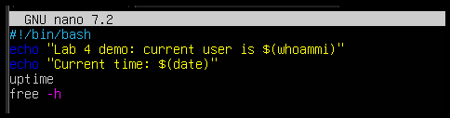
- Script made executable.
- Script executed successfully.
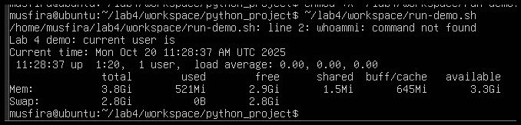
- (Optional) Script run with sudo privileges.
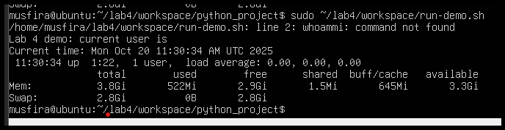

Exam Evaluation Questions
Q1 – Remote Access Verification
- Remote SSH connection established.
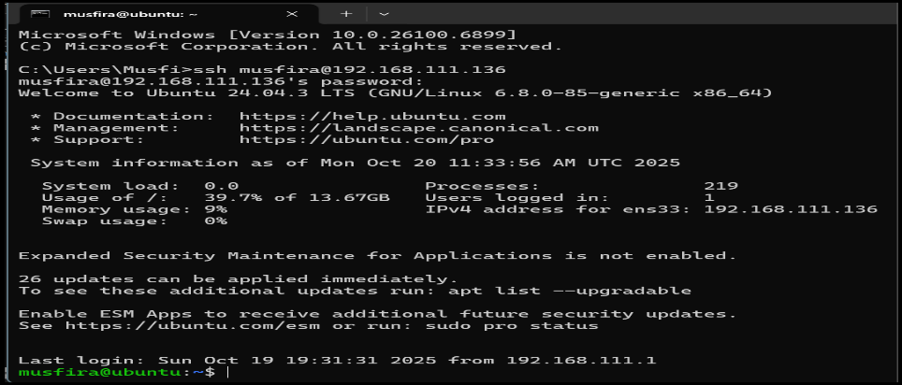
- Verified user and home directory.
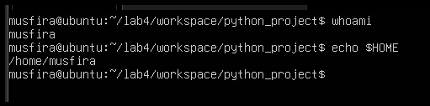
- Confirmed correct host system.
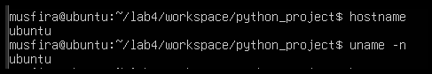

Q2 – Filesystem Inspection for Forensic Evidence
- Root directory listing.
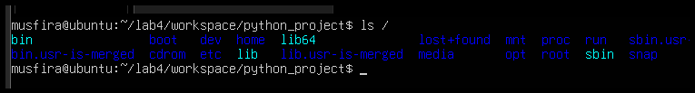
- OS version and release info.
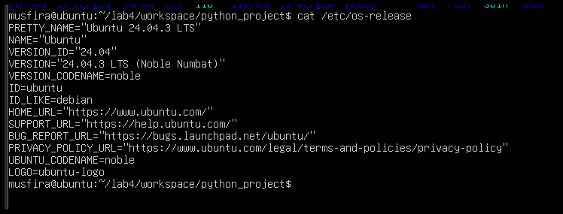
- Listings for /bin, /sbin, /usr, /opt, /etc, /dev, /var, /tmp.
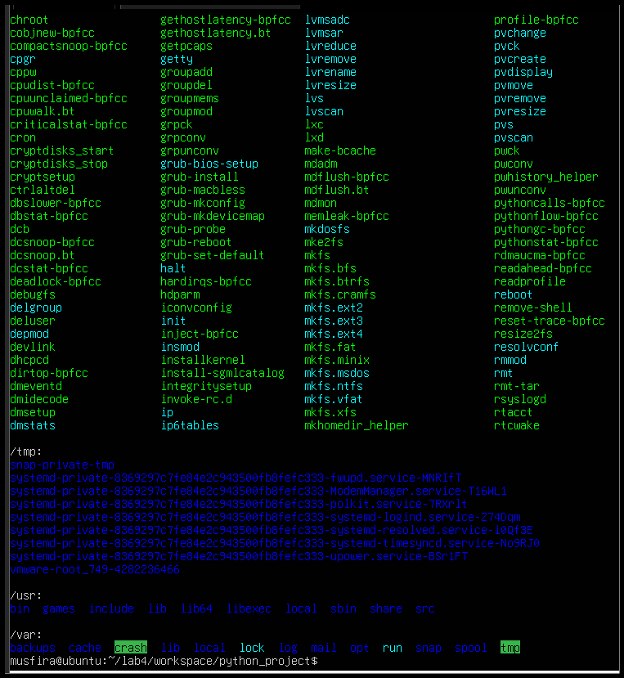
- Hidden files in home directory.
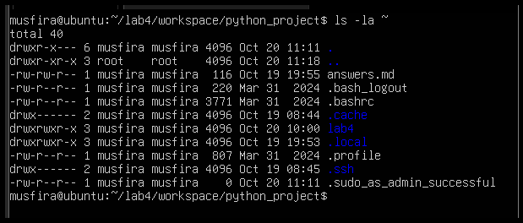
- Markdown summary of findings.
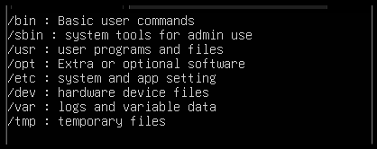

Q3 – Evidence Handling & File Operations
- Created structured workspace.
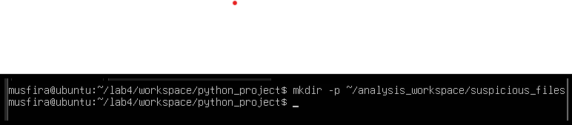
- Three text files created (one hidden).
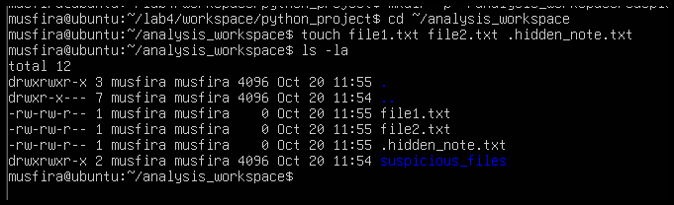
- Backup copy, rename, and delete demonstrated.
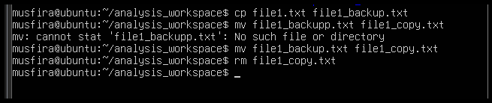
- Copied workspace as backup folder.
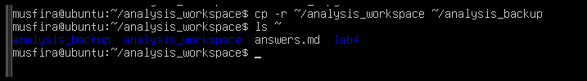
- Displayed command history for documentation.
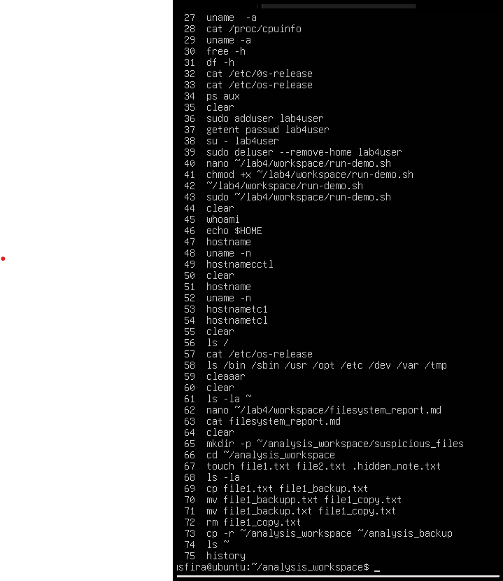
- Shown tab auto-completion example.
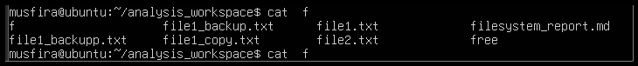

Q4 – System Profiling & Process Monitoring
- Kernel and OS version.
- CPU, memory, and disk stats.
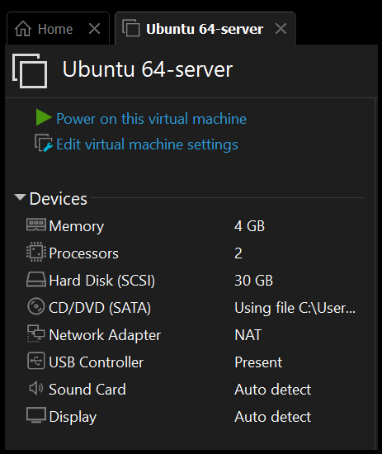
- Running processes list.
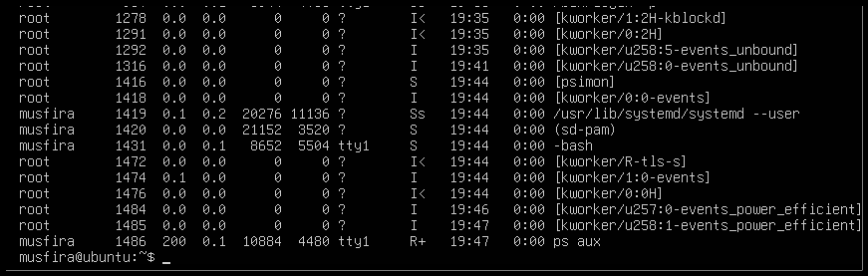

Q5 – User Account Audit & Privilege Escalation Simulation
- New user lab4user added.
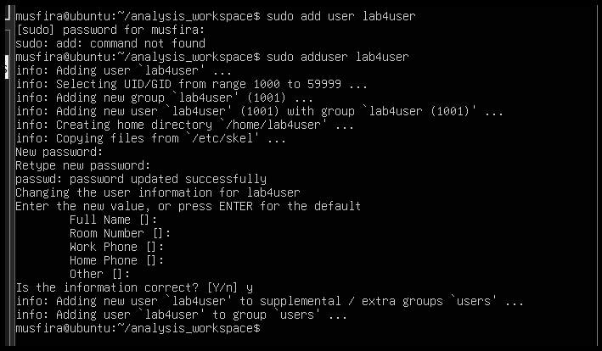
- Verified user record in system.
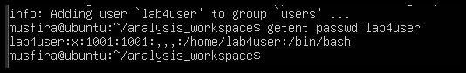
- Logged in as lab4user.
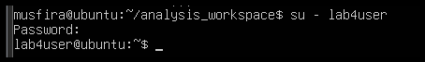
- Attempted sudo command (denied).
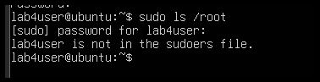
- Returned to main analyst account.
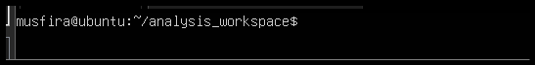
- Checked authentication logs for login attempts.
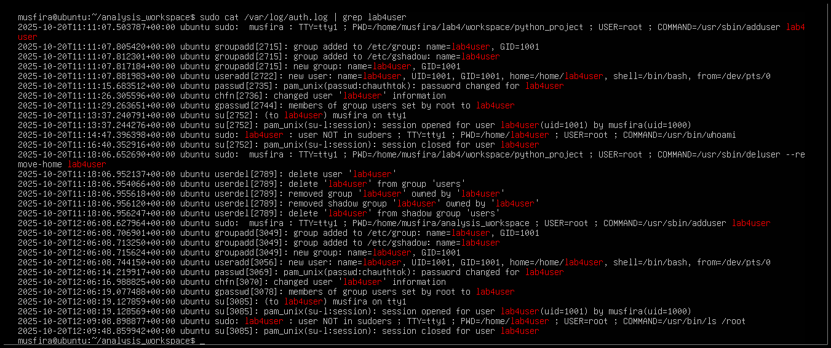
- (Optional) Deleted test user after audit.
